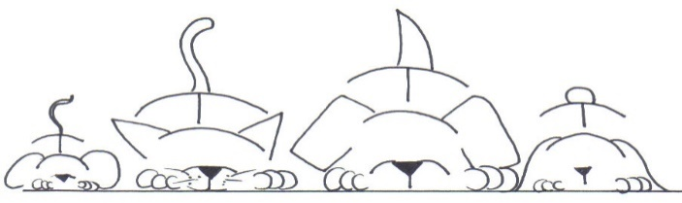

Chandlers Ford Veterinary Surgery

**A massive congratulations to our Registered Vet Nurse Lana and her partner Nick on the birth of their beautiful baby girl Mila!**

**Introducing our new starters:**

**Congratulations:**

Please join us in congratulating our Receptionist Sara Rose on passing her ‘Bronze Level Accredited Veterinary Receptionist Award’ and her ‘Competent Veterinary Dispenser Award’. Her certificates are displayed in reception.

Please join us in also congratulating our Veterinary Care Assistant Jo Hillman on passing her ‘Virbac Dental Care Course Award’. Her ‘Competent Veterinary Dispenser Award’ and her ‘Bronze Level Accredited Veterinary Receptionist Award’. Her certificates are displayed in reception.

**To find out more visit our website:**[**http://www.chandlersfordvets.co.uk**](http://www.chandlersfordvets.co.uk)

**Facebook page: https://www.facebook.com/chandlersfordvetsurgery**

How to help keep Hedgehogs safe this time of year:

Always check or move your bonfire before lighting it. Stacked logs and leaves create the perfect nesting environment for hedgehogs.

Check sheds and summerhouses for hedgehogs before closing and locking doors.

Compost heaps create environment for hedgehogs to forage and hibernate. Check for any signs of hedgehogs before turning over your compost.

If you disturb a hibernating hedgehog, cover them with leaves and put out some food and water in case they wake up and re locate.

If you see a hedgehog out in daylight, please seek advice from us or Hart Wildlife: 01420562335

Pets and Fireworks:

Make sure to keep your pets indoors where they are safe.

Walk your dogs during the day when it’s quiet.

Close blinds and curtains to block out the flashes of fireworks.

Close windows and put on some music or the TV to mask the sounds of the fireworks.

Your pets can benefit from a den area/safe space to hide in.

Please get in touch for any further advice or help!

Welcoming Georgia Cousins – Our new Receptionist.

Welcoming Jo Haywood – Our new Receptionist.

Welcoming Simon Spencer – Our new Veterinary Nurse Assistant.

Autumn 2022 Newsletter